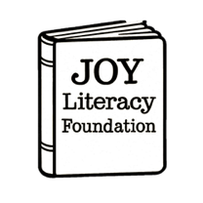
JOY Literacy Foundation
Scholarship Application

Full Name:
Email Address:
Phone Number:
Home Mailing Address:

How did you find out about this scholarship?
Are you available for a 10-minute interview (Y/N) ?

University Name:
Major: Minor:
Expected Graduation Date:
Are you working on a B.A., B.S., M.A., or doctorate?
If you are currently teaching, what position?

List academic honors you received in high school.

List volunteer or work experience related to literacy.

If you are a member of any professional or student organizations related to education or literacy, please list the organization(s) and describe your role/impact in the organization.

